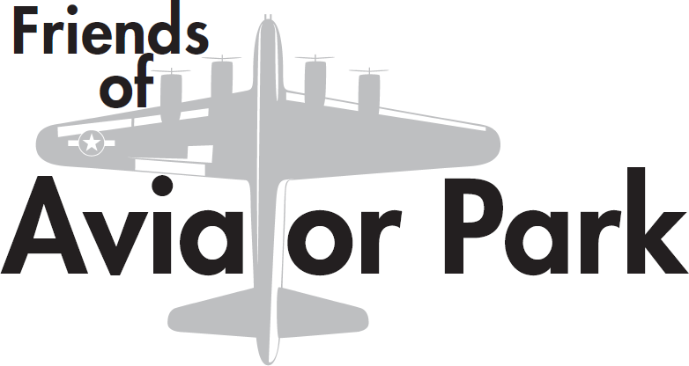
Friends of Aviator Park
Membership Form

Our Mission
The Friends of Aviator Park is an association of friends, neighbors and organizations dedicated to the revitalization and preservation of Aviator Park for the benefit of the entire community and future generations.

Our Members
Our members are part of the growth and stability of our neighborhood. Your membership helps support our many initiatives, services, and activities that make us a strong, vibrant community. Most importantly, your participation can help to ensure the vitality, strength, safety, and success of our wonderful neighborhood.

Our Neighborhood Association
Become a member of FOAP. All Logan Square residents, businesses, and institutions are welcome.
Be in the know, Be connected, Be heard, Be involved –Belong to Friends of Aviator Park. Join us!

Friends of Aviator Park Board
-------------------------------------------------------------------------------------------------------------------------------------------------------------------------------------------------

Annual membership is payable by check to FOAP and runs July 1 – June 30.

Mail checks to: FOAP Membership, ℅Wendy Blume, 117 N.. Lambert St, Philadelphia, PA 19103

Residential Commercial
___ Household $25.00 ___ Corporate Friend $250
___ Senior Citizen/Student $10.00 ___ Corporate Booster $500
___ Booster $50.00
___ Patron $100.00

I am interested in the following committee(s).

___ Events
___ Beautification
___ Membership
___ Other (please specify) ____________________________

Name(s) ____________________________________________________________________________

Address: ____________________________________________________________________________

Email: ______________________________________ Phone: _________________________________

Please include your Email address so that you can receive FOAP communications.

